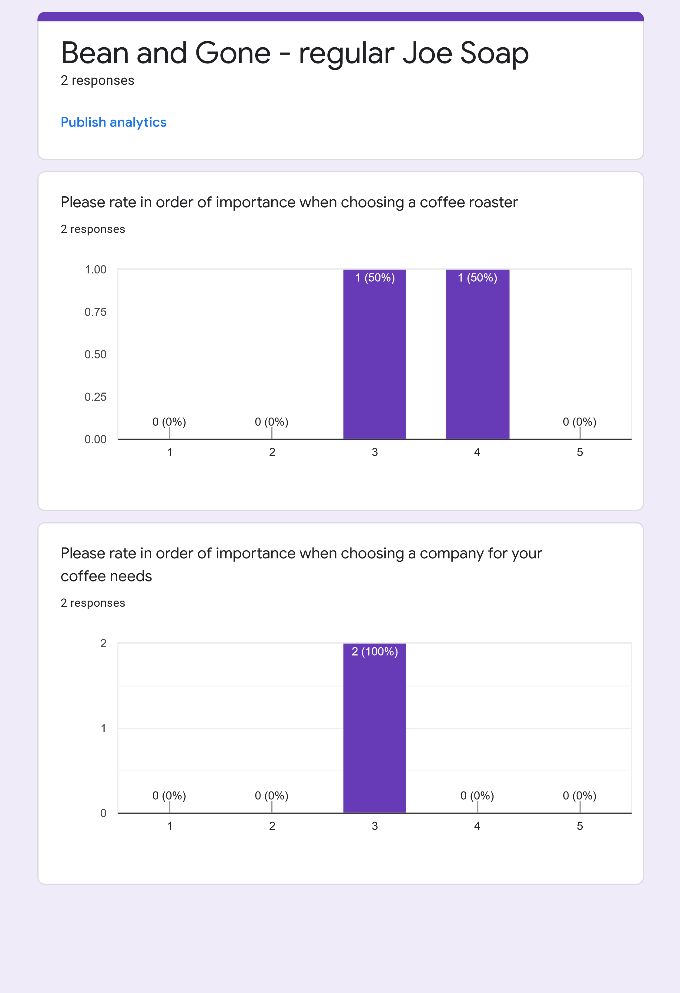

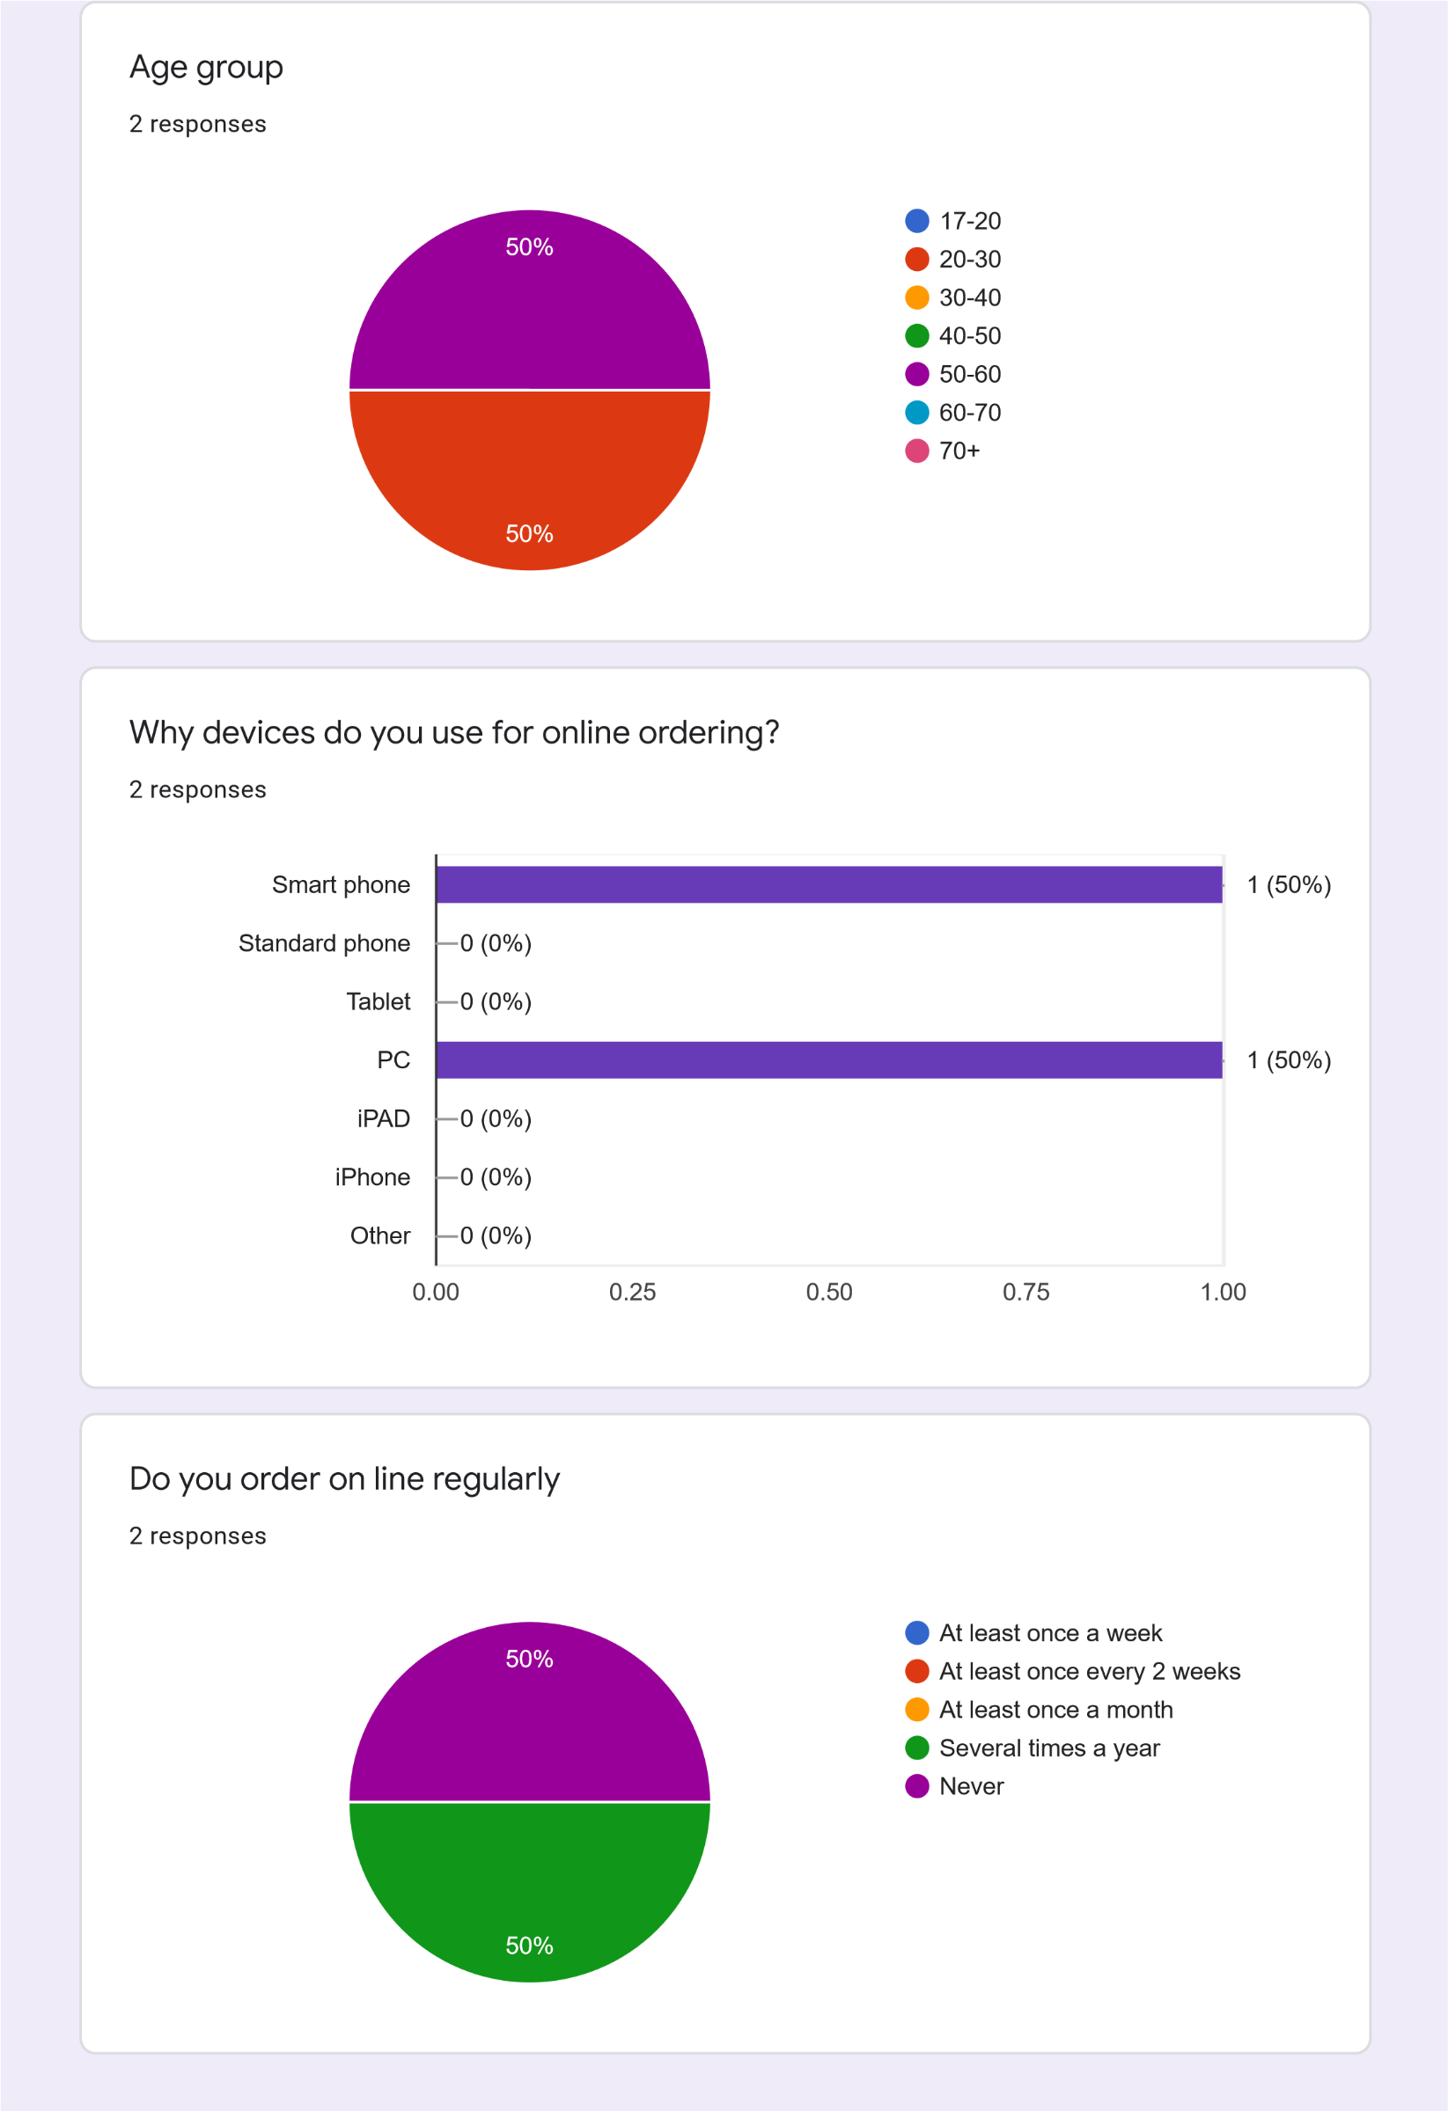

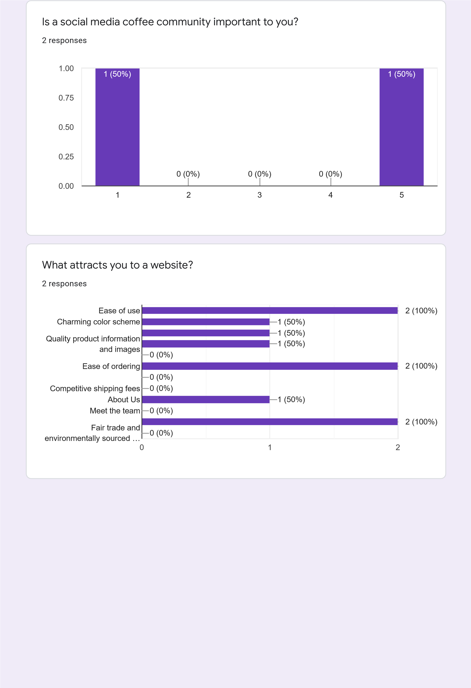

Which colour would your prefer to see in a webpage?

responses

2

Do you prefer dark mode of light mode?

2

responses

If you subscribe, how often would you like a delivery?

responses

2

1

2

3

4

5

0.00

0.25

0.50

0.75

1.00

)

(0%

0

1

(50%

)

(0%

)

0

0

(0%

)

1

(50%

)

Dark mode (gray/black)

Light mode (white/light gray)

100

%

Every week

Every 2 weeks

Once a month

Once a quarter

50

%

50

%

|  |
| --- |
| This content is neither created nor endorsed by Google. [Report Abuse](https://docs.google.com/forms/d/1AVBIFKs7RzEq80WR76L-K4-vKEKKqCXVh9pusoK2mwo/reportabuse) - [Terms of Service](https://policies.google.com/terms) - [Privacy Policy](https://policies.google.com/privacy)  [Forms](https://www.google.com/forms/about/?utm_source=product&utm_medium=forms_logo&utm_campaign=forms) |